**Tableau**

 Section --- Time series, aggregation, granularity, filters.

* Unemployment statistics in us
* Reference from <https://fred.stlouisfed.org/series/UEMP27OV#0>
* By using these statistics we can show high level aggregation and granularity, and also shows low level of those.
* By adding more number of filters we can see high of granularity.

Section -- Maps, Scatterplots, and Your First Dashboard.

* Joining the tables using inner join
* Creating another sheet **Customer Scatter plot** and some data in the sheet like sales and profits, and for granulation we add or drag  customer name on to the detail marks.
* We add profit margin = sum of profits / sum of sales on color marks.
* Here we apply **common filter for all sheets such as Year of order = which shows results of all sheets in same year.**
* Creating the **Dashboards** and dragging the sheets created before and got know about objects.
* Adding an **interactive actions** to the dashboard using by selecting sheet and selecting the **use as filter option** in the more options shown by the sheet **or** selecting actions option in the dashboard shown above and filter the options needed to use.
* **Highlighting** the interactive actions by apply highlights in actions in dashboard above. Before applying identify the difference between **Actions and Highlights**, when you appy action, it reflect on multiple fields, whereas highlights has advantage that it can specify the field when you cursor on it. Before applying the highlights you should add more granularity or details for specification to be shown.

Section --- Joining and Blending Data, PLUS Dual Axis Charts

* Types of joins -- inner join, left outer join, right outer join, full outer join.

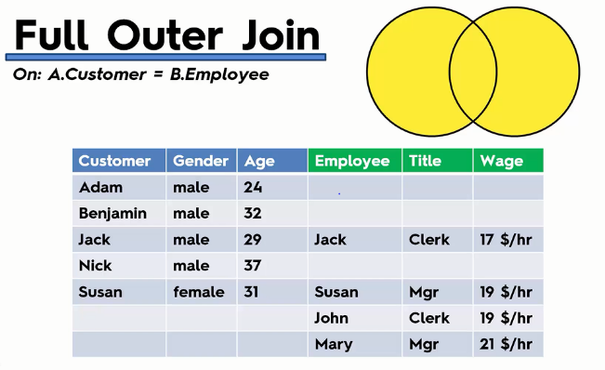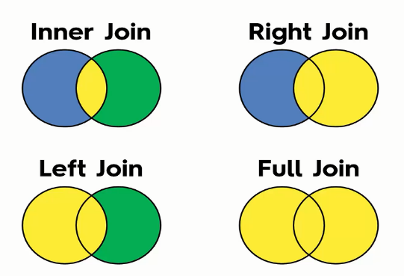

* **Duplicates in joins** happens when 2 tables are applying inner join, column fields may not same for both but while joining with similar field in both tables, the other fields in the table duplicates themselves for filling the empties.
* **Joining on multiple fields**

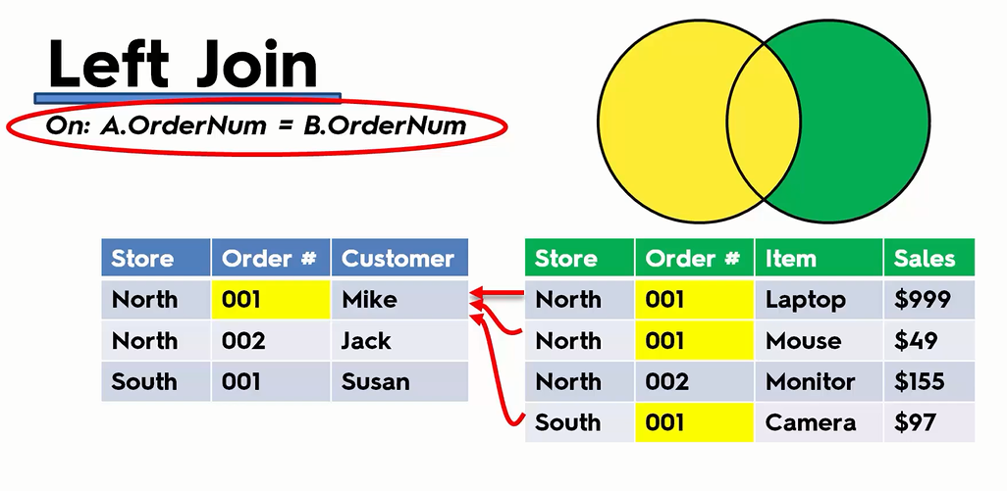

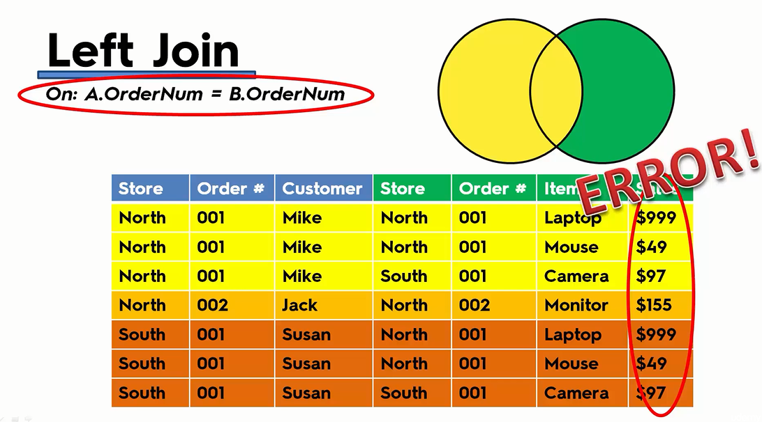

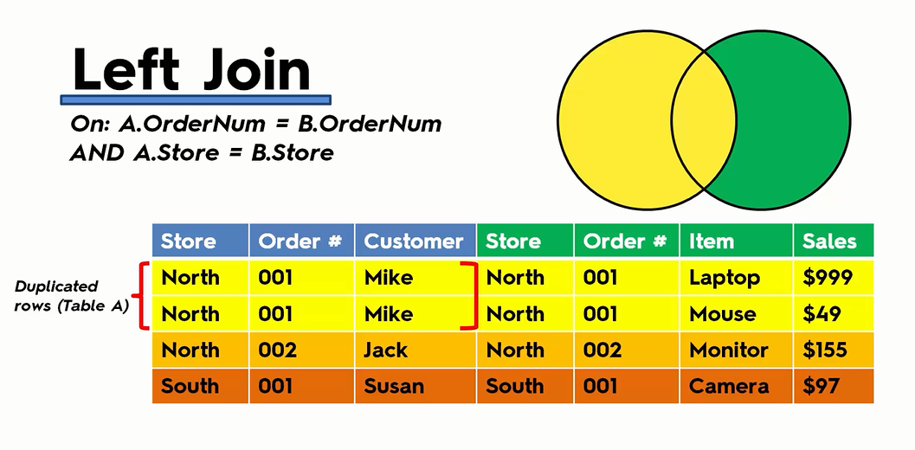

* Joining 2 tables cannot be done always due to **high granularity and due to different columns data source,** So we use blending technique, where we take other table in another data source.
* Data blending --- it is smart way of joining, where we use 2  data sources for blending of data. If we take data from 1 data source, tableau automatically shows red blend symbol(shows in another data source) which replicates same data found in another source. It means it is ready to get blend.
* Therefore another way of blending is by selecting Data from above menu and choose edit blend relationships for blending of other data source perfectly, if there are not.
* **Dual axis chart**----- where we blend the 2 data sources and apply dual axis and synchronize axis.
* Creating a **calculation field** for showing the difference in **dual axis blends**(advance concept).

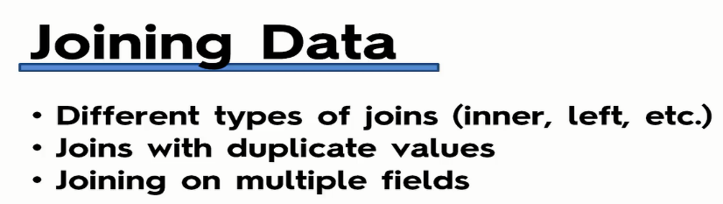

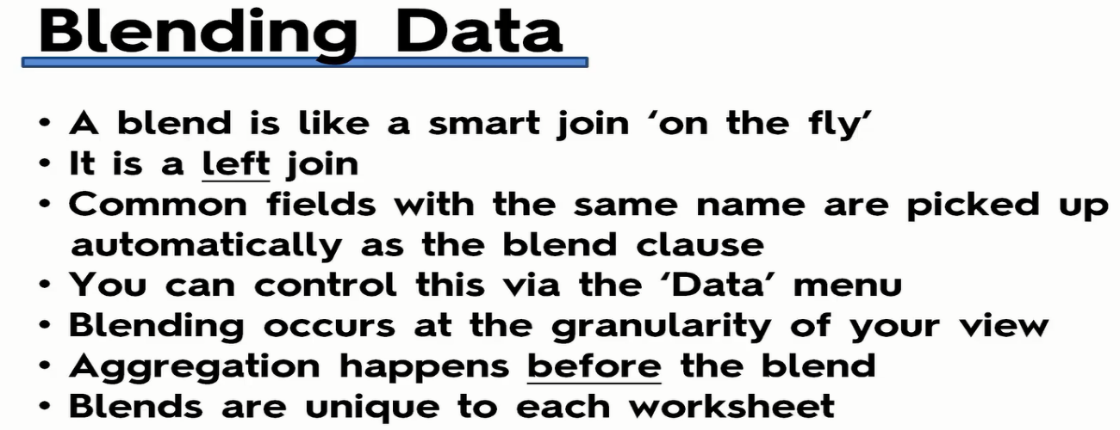

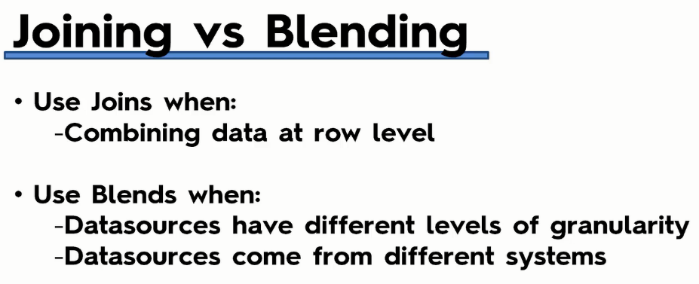

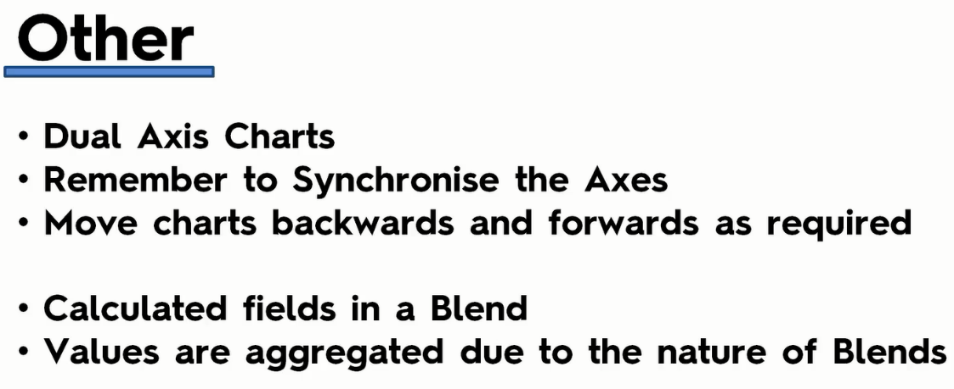

Section -- Table Calculations, Advanced Dashboards, Storytelling

* Today's dataset is **dummy data for an imaginary bank operating in the UK.**
* The task is find what type of customer in the particular region and see more development in the region for that type of more customers to get joined in future.
* Mapping how to set the geographical locations --- while dragging the dataset, if any unknown found or shown in right side corner, by clicking and filtering according to the given task like country or continent selection automatically, you can observe the longitude and latitude with globe symbol added to the left side in measures set.
* Creating Table Calculations for Gender -- like selecting by right clicking on the number of records file, you can find quick calculation, in that percentage in total shows the result.
* Creating Bins and Distributions For Age -- while creating age sheet, we created a bin which means difference in columns like 15,20,25-- 5 difference.
* Leveraging the Power of Parameters -- by right clicking on the left side where tables present, you see create parameters, by selecting it we can create parameter to see insights in particular range. After creating the parameter, you have to add that parameter to respective data set by right clicking on it, you can see edit button, in edit drop you have to created parameter to get applied.
* Create a Tree Map Chart --- if needed
* Creating a Customer Dashboard -- where here added background colors or images and adjusted all sizes to fit.
* Advanced Dashboard Interactivity -- by applying filters on every sheet
* Analyzing the Customer Segmentation Dashboard.
* Creating a Storyline -- by dropping down the dashboard to the respective story. Each story note should have what this analysis upon in step by step process or describe by selecting one major place or graph or depending upon your challenge query, you should write the difference or changing values should be mentioned in that note. Whereas here we can **Annotate** option by selecting particular place of sheet and write the specification of that place , which is like note for the better insight of that visual.